PROJECT PROPOSAL FOR INNOVATE AND LEARN GRANT

Voice Indonesia

Please read thoroughly the Grant Manual for guidelines on how to apply, what is expected of grantees, criteria, schedule, the granting process, and the example of learning agenda in Indonesia.

Innovate and Learn Grant is for groups and organisations to test, review, and/or scale up new approaches to address the marginalisation, discrimination, and exclusion experienced by Voice target groups.
- The time period for the grant is from 12 to 24 months.
- The budget can be from EUR 5,000 to EUR 200,000 (approx. IDR 70,000,000 to IDR 2,800,000,000).

- PROJECT OVERVIEW
A.1. Project Title:

A.2. Name of the [Lead] Applicant Organisation:

Address:

Telephone No.: | Email Address:
Contact Person and Position: | Alternate Contact Person:
Organisation National Registration Details: | Date Registered:
A.2 (b). Name of Co-applicant (s) – List names of organisations if application is by a consortium.

A.3. Project Duration:

A.4. Proposed Budget:
EUR
or IDR
A.5. Geographical Coverage:

A.6. Target Groups:
Select all that apply, minimum two (2), to ensure intersectionality.
( ) Persons with disability
( ) Age-discriminated groups (i.e. youth and elderly)
( ) LGBT community
( ) Indigenous people and ethnic minorities
( ) Women facing exploitation, abuse and violence
A.7. Thematic Areas:
Select all that apply.
( ) Increasing access to productive resources (i.e. finance, land, and water) and employment
( ) Increasing access to social services, health and education in particular
( ) Strengthened space for political participation
A.8. Executive Summary:
Brief but specific statement of the proposed project objectives, methods and impact. Be succinct and to the point! (max. 500 words)

- PROJECT NARRATIVE

Please see the learning cycle below to help you understand better the intention of Innovate and Learn Grant and how to fill the forms/ questions.
  - Problem
What problem(s) are you addressing?
  - Reflection
What’s the learning question(s) you want to answer?
  - Explore
Why do you want to answer the learning question(s)?
What has been done before?
  - Test
What are you doing differently?
What is the innovative approach(es) you wish to test or scale-up, in order to answer the learning question(s)?
What methodology will you use to evaluate the approach?

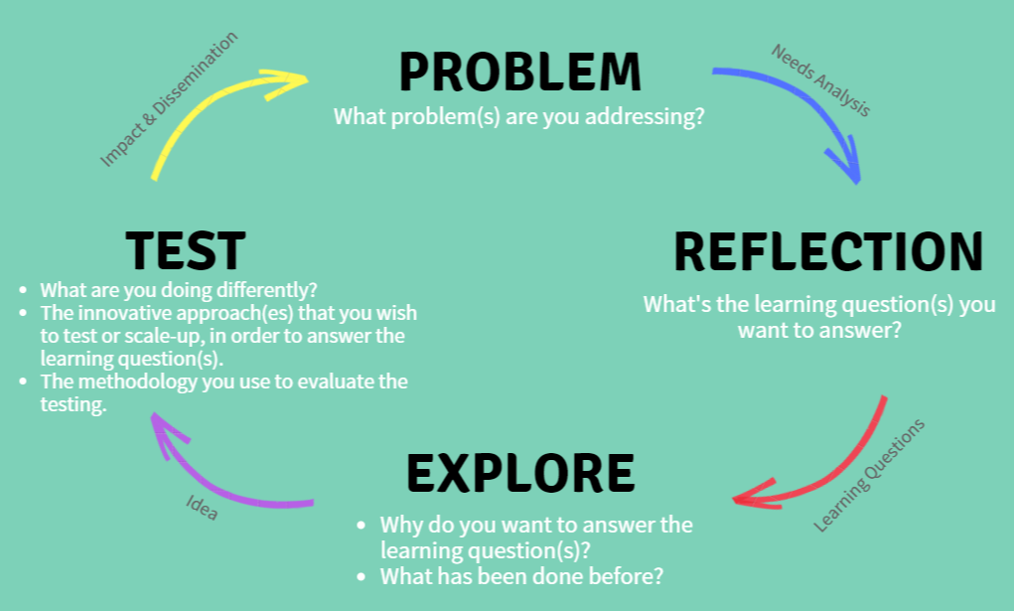

B.1. Problem: Needs Analysis
Tell us the issues you face or faced by the target group(s) you will be working with. Focus on the specific needs that you wish to address with this project, especially in regards to access to resources, services and participation in decision making. (max. 300 words)

B.2. Reflection: Learning Questions
What do you need or want to learn in order to address the issues you mentioned? What questions are you asking in order to take advantage of the opportunities presented? These must be at the core of the innovation you want to test or scale-up. They need to be answered at the end of the grant period. Add as many as you want answer.

Example:
- Understand the factors that improve collaboration between the local government and different marginalised groups.
  - Are local government leaders more willing to support civil society projects when presented with research evidence?
  - Does presenting already drafted village laws or ordinances make it easier for local government officials to engage with marginalized groups?

- Understand the design and usability of mobile applications to enhance participation of marginalised groups in the decision-making process.
  - What features can be added to a mobile app in order for people with disabilities to monitor spending on social services?
  - Can a mobile game be designed in order for youth to understand sexual and reproductive rights?

- …

B.3. Explore: Idea
Describe (a) what interventions have been tried before to answer the questions above; (b) what opportunities do you see to do something differently; (c) how the grant will allow you to work differently or more more effectively; and (d) other organizations or individuals you will collaborate with. (max. 300 words)

B.4. Test: The Innovation
Describe the innovative approach(es) you wish to test, review, and/or scale-up to answer the learning questions. and address the issues mentioned above. Include the following: (a) the activities to be completed; (b) the degree to which the activities are supported by research and/or evidence; (c) the specific goals and outcomes; (d) a fuller description of the people the project will support (i.e. race/ethnicity, age, disability status, gender identity, sexual orientation, socioeconomic status, religion/belief, and geographic location); (d) how it addresses the Voice themes. Specify the study design, study area (geographic), required preparation for fieldwork (if any), sampling criteria, methods of data collection and data processing. Also, outline any testing or action research you wish to undertake; include these in Table A (Work Plan). (max. 500 words)

B.5. Monitoring/Reflection/Reporting
Describe how you will keep track, reflect and record your learning throughout your project. How will you know that the activities are successful? How can your learning direct you in your next steps? How will find out if the project requires changes or realignment? Include the frequency and methods for reflection/learning within your team. Provide an appropriate budget for these activities. (max. 200 words)

B.6. Impact and Dissemination
How will others gain knowledge through your learning? What do you think others can do with the knowledge gained? How will you share the knowledge gained from this project? Describe in the detail the plan to disseminate the findings/learnings, how the target audience will use it, what products need to be developed, and the frequency and methods of reflection/learning with all relevant stakeholders. Include these in Table A. (max. 200 words)

B.7. Risk Assessment

Describe the factors that could limit you from fully implementing the project. How do you plan on minimizing their impact?
 | Risk | Likelihood  (L-low, M-medium,  H-high) | Mitigation Strategy
1.
2.
3.
…

B.8. Additional Comment
Use this section to make any additional comment about your proposal. Please also make comment on any help you might need to implement this project.

- ORGANISATIONAL BACKGROUND

C.1. Overview of the Organisation
Describe the vision(s)/ goal(s) of your organisation, your main programmes or activities, your organisation’s most important accomplishments/ outcomes, and what is unique about your organisation. (max. 500 words)

C.2. Geographical Reach and Professional Character
Tell us where your organisation has implemented projects. Describe what principles does your organisation value. (max. 200 words)

C.3. Stakeholder Participation
Tell us how you develop your activities/ programmes, how do you interact with the target group(s), and plan your activities with them? (max. 200 words)

C.4. Partners and Linkages
Please describe your previous and current partners, networks, and other linkages. What kind of engagement do you have with them? (max. 200 words)

C.5. Donors
Please tell us your previous (in the last 2 years) and current donors and contact details of at least 2 of them.
(max. 200 words)

C.6. Human Resources
What is the size of your organisation and the total number of full-time and part-time employees including a breakdown by gender identity?

C.7. Governance
Provide your organisation’s Board of Directors or similar governing body, the names, and contact information for the Board Chair or President and other members. In addition, provide information on how often the board meets in the last two years.
Full Name | Position | Contact Detail

C.8. Transparency and Accountability
Tell us how your organisation demonstrates accountability and transparency in your commitments to the donors, communities, and your target groups. (max. 200 words)

Table A: Work Plan
Project Objective/s:

Description of Activities | Timeframe (months) |  |  |  |  |  |  |  |  |  |  |  | Expected Results
 | 1 | 2 | 3 | 4 | 5 | 6 | 7 | 8 | 9 | 10 | 11 | 12
1.
1.1
1.2
2.
3.
4.
5.
6.
7.
8.
9.
...
Note: You may develop your own Excel Spreadsheet in completing the Work Plan. Please justify the timeframe according to your proposed project duration.

TABLE B: Governance and Reporting Requirements per 6 months.
Milestones (or Key Achievements) | Timeframe (months – please adjust with your project duration)
 | 1 | 2 | 3 | 4 | 5 | 6 | 7 | 8 | 9 | 10 | 11 | 12
Milestone 1: 25% of Contract
Production of agreed Work Plan and Final Budget.
Signed Grant Agreement.
Milestone 2: __% of Contract
Progress Report submission and approval.
List activities/ results to be completed by the milestone.
Milestone 3: __ % of Contract
Progress Report submission and approval.
List activities/ results to be completed by the milestone.
Milestone 4: __ % of Contract
Progress Report submission and approval.
List activities to be completed by the milestone.
Milestone 5: 10 % of Contract
Final Report submission and approval.
- Milestones will be paid for key achievements completed and approved by both parties every 6 months.
- The 1st Milestone payment will be paid upon signed Grant Agreement.
- Milestone payments will be an agreed % of the total contract value depending upon activities to be completed as per the agreed work plan.
- Milestone payments 2 (3, 4...) will only be paid upon submission and approval of Progress Reports (narrative and financial) of previous milestones.
- The last milestone is the completion of final report submission and approval.
- Further conditions will be arranged in the Grant Agreement.

