PROJECT PROPOSAL FOR INNOVATE AND LEARN GRANT
Voice Cambodia

Please read thoroughly the Grant Manual for guidelines on how to apply, what is expected of grantees, criteria, schedule, the granting process, and the example of learning agenda in Cambodia.

Innovate and Learn Grants are for groups and organisations to test or review and scale new approaches to address the marginalisation, discrimination, and exclusion experienced by Voice target groups.
- The time period for the grant is from 1 to 2 years.
- The budget can be from EUR 5,000 to EUR 200,000

- PROJECT OVERVIEW
A.1. Project Title:

A.2. Name of the [Lead] Applicant Organisation:

Address:

Telephone No.: | Email Address:
Contact Person and Position: | Alternate Contact Person:
Organisation National Registration Details: | Date Registered:
A.2 (b). Name of Co-applicant (s) – List names of organizations if application is by a consortium

A.3. Project Duration:

A.4. Proposed Budget:
EUR
A.5. Geographical Coverage:

A.6. Target Groups:
Select all that apply, minimum two (2), to ensure intersectionality.
( ) Persons with disabilities
( ) Age-discriminated groups (i.e. youth and elderly)
( ) LGBTQI community
( ) Indigenous people and/or ethnic minorities
( ) Women facing exploitation, abuse and/or violence
A.7. Thematic Areas:
Select all that apply.
( ) Increasing access to productive resources (i.e. finance, land, and water) and employment
( ) Increasing access to social services, health and education in particular
( ) Strengthened space for political participation
A.8. Executive Summary: (max. 500 words)
Brief but specific statement of the proposed project objectives, methods and impact.
Be succinct and to the point!

- PROJECT NARRATIVE

Please see the learning cycle below to help you understand better the intention of Innovate and Learn Grant and how to fill the forms/ questions.

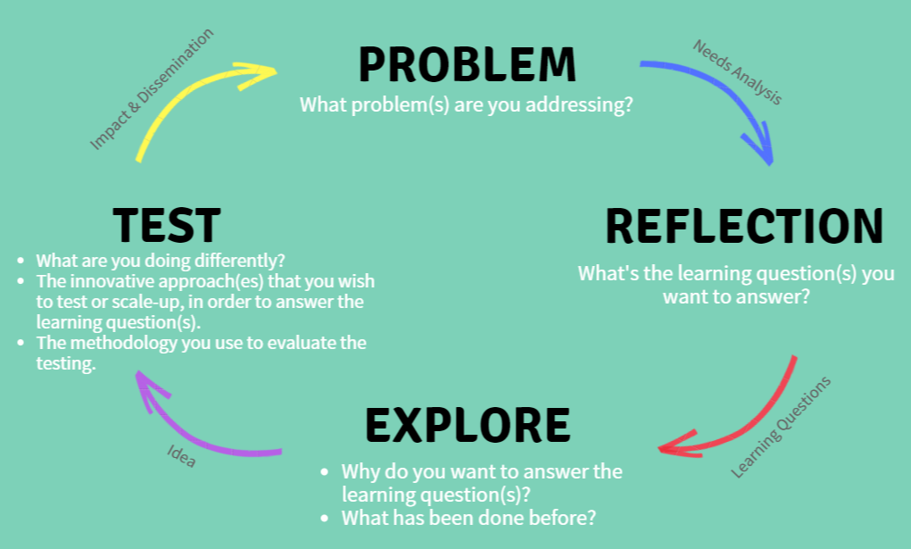

B.1. Problem: Needs Analysis
Tell us the issues you face or faced by the target group(s) you will be working with. Focus on the specific needs that you wish to address with this project, especially in regards to access to resources, services and participation in decision making. (max. 300 words)

B.2. Reflection: Learning Questions
What questions will this proposed project try to answer? These questions are at the core of the innovation you want to test or scale-up. They will need to be answered at the end of the grant period.

“The usefulness of the knowledge we acquire and the effectiveness of the actions we take depend on the quality of the questions we ask.” Eric Vogt

- …

B.3. Explore: Idea
Explain why your organisation wishes to answer these learning questions, include the following considerations: (a) what interventions have been tried before; (b) what opportunities for innovation do you see; (c) how the learning questions fit within your organisation’s strategic plan; (d) how the grant will allow you to work differently or more effectively; and (e) any other organisations or individuals who are collaborators in this endeavour. (max. 300 words)

B.4. Test: The Innovation
Tell us about the innovative approach(es) that you wish to test, review or scale-up in order to answer the learning questions. Provide a description, including the following: (a) the activities to be completed; (b) the degree to which the activities are supported by research and/or evidence; (c) the specific goals and outcomes; (d) a fuller description of the people the project will support (i.e. race/ethnicity, age, disability status, gender identity, sexual orientation, socioeconomic status, religion/belief, and geographic location); and (d) how it addresses the Voice themes. (max. 250 words)

The Methodology Used to evaluate the innovation
How will you evaluate the success of the project? Include specifics of the study design, study area (geographic), required preparation for fieldwork (if any), sampling criteria, methods of data collection and data processing and collection. Also, outline any testing or action research you wish to undertake. Include these in Table A (Work Plan). (max. 250 words)

B.6. Impact and Dissemination
How will others gain knowledge through your learning? What do you think others can do with the knowledge gained? How will you share the knowledge gained from this project? (Describe in the detail the plan to disseminate the findings/ learning products and how it is expected the target audience will use it). Include these in Table A. (max. 200 words)

B.7. Monitoring/Reporting
This section is for you to describe how you will keep track of your project. How will you know that the activities are successful? How will you correct for errors or mistakes in assumptions? (max. 200 words)

B.8. Risk Assessment
Describe the risks that could limit the success of the project and your plans to mitigate this risk.
 | Risk | Likelihood  (L-low, M-medium,  H-high) | Mitigation Strategy
1.
2.
3.
…

B.9. Additional Comment
Use this section to make any additional comment about your proposal. Please also make comment on any help you might need to implement this project.

- ORGANISATIONAL BACKGROUND
C.1. Overview of the Organisation
Describe the vision(s)/ goal(s) of your organisation, your main programmes or activities, your organisation’s most important accomplishments/ outcomes, and what is unique about your organisation. (max. 500 words)

C.2. Geographical Reach and Professional Character
Tell us where your organisation has implemented projects. Describe what principles does your organisation value. (max. 200 words)

C.3. Stakeholder Participation
Tell us how you develop your activities/ programmes, how do you interact with the target group(s), and plan your activities with them? (max. 200 words)

C.4. Partners and Linkages
Please describe your previous and current partners, networks, and other linkages. What kind of engagement do you have with them? (max. 200 words)

C.5. Donors
Please tell us your previous (in the last 2 years) and current donors and contact details of at least 2 of them.
(max. 200 words)

C.6. Human Resources
What is the size of your organisation and the total number of full-time and part-time employees including a breakdown by gender identity?

C.7. Governance
Provide your organisation’s Board of Directors or similar governing body, the names, and contact information for the Board Chair or President and other members. In addition, provide information on how often the board meets in the last two years.
Full Name | Position | Contact Detail

C.8. Transparency and Accountability
Tell us how your organisation demonstrates accountability and transparency in your commitments to the donors, communities, and your target groups. (max. 200 words)

Table A: Work Plan
Project Objective/s:

Description of Activities | Timeframe (months) |  |  |  |  |  |  |  |  |  |  |  | Expected Results
 | 1 | 2 | 3 | 4 | 5 | 6 | 7 | 8 | 9 | 10 | 11 | 12
1.
1.1
1.2
2.
3.
4.
5.
6.
7.
8.
9.
...
Note: You may develop your own Excel Spreadsheet in completing the Work Plan. Please justify the timeframe according to your proposed project duration.

TABLE B: Governance and Reporting Requirements
Milestones (or Key Achievements) | Timeframe (months)
 | 1 | 2 | 3 | 4 | 5 | 6 | 7 | 8 | 9 | 10 | 11 | 12
Milestone 1: 25% of Contract  Production of agreed Work Plan and Final Budget.  Signed Grant Agreement. | √
Milestone 2: __% of Contract
Progress Report submission and approval.
List activities/ results to be completed by the milestone.
Milestone 3: __ % of Contract
Progress Report submission and approval.
List activities/ results to be completed by the milestone.
Milestone 4: __ % of Contract
Progress Report submission and approval.
List activities to be completed by the milestone.
Milestone 5: 10 % of Contract
Final Report submission and approval.
- Milestones will be paid for key achievements completed and approved by both parties.
- The 1st Milestone payment will be paid upon signed Grant Agreement.
- Milestone payments will be an agreed % of the total contract value depending upon activities to be completed as per the agreed work plan.
- Milestone payments 2 (3, 4...) will only be paid upon submission and approval of Progress Reports (narrative and financial) of previous milestones.
- Further conditions will be arranged in the Grant Agreement.

