PROJECT PROPOSAL APPLICATION FORM
VOICE NIGERIA INNOVATE & LEARN GRANT

This is a unique opportunity provided by Voice to learn and explore under the project, to test and scale new approaches. This grant is open to both CSOs and social enterprise who are also working on social issues. It is available for a minimum of 5,000 to a maximum of €200,000. The life of projects under this grant must not exceed 24 months

PROJECT OVERVIEW
1. Title of the project: (Catchy, Brief & Concise- must be related to the specific innovative idea the project is bringing)

2. Name of the Applicant Organisation/Co-Applicant(s):

3. Contact Details of the Applicant:
Tel:

Email:

Address:

Contact Person & Position:

(phone number if different from above):

Alternative Contact Person and Position:

(Phone number):
4. Introduction:
a. Project Duration:

b. Proposed Budget (please attach full budget): €

c. Focal State(s):

d. Target Groups: Select all that apply.
( ) Persons with disability
( ) Age-discriminated groups (i.e. youth and elderly)
( ) LGBT community
( ) Indigenous people and ethnic minorities
( ) Women facing exploitation, abuse and violence
e. Thematic Areas: Select all that apply.
( ) Increasing access to productive resources (i.e. finance, land, and water) and employment
( ) Increasing access to social services, health and education in particular
( ) Strengthened space for political participation

5. Short project summary (Maximum of 500 words): In a precise and concise manner, tells us about the innovation your project wants to bring. Please note that this is not time to list out the outputs and/ activities of the project.

6. Project Narrative:
Please refer to the cycle below for better understanding of what the Innovate & Learn Grant tends to achieve

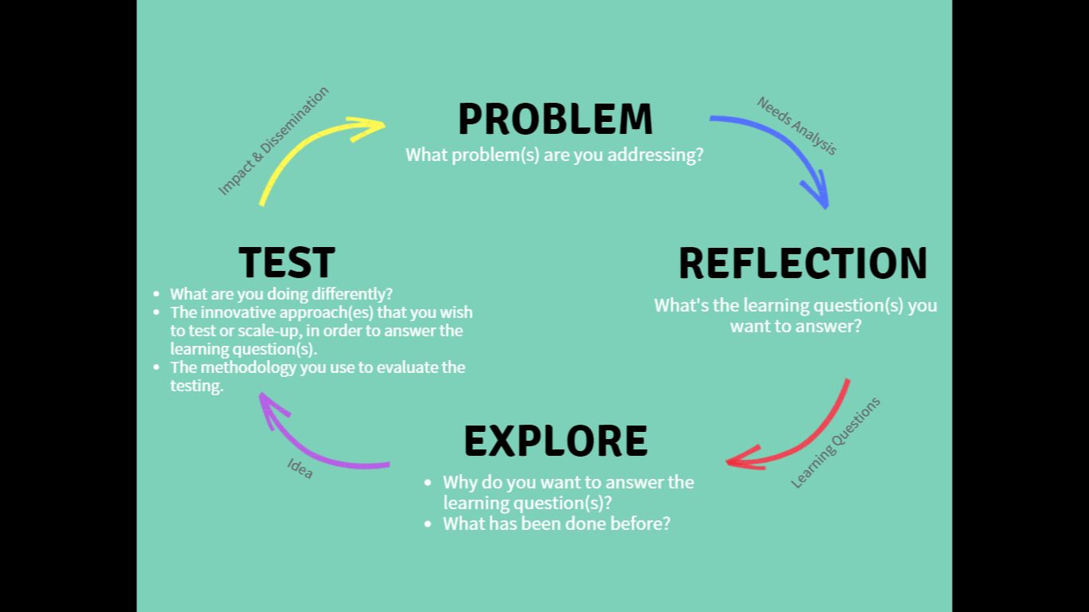

6a. Needs/Problem Analysis (Maximum of 250 words):
In a precise and concise manner, tells us about the social issue(s)- lack of social services, resources or space for political participation/freedom of expression; faced by your target beneficiaries, that your innovation wants to address. Please present the problem/issue(s) in bullet points with some explanation

6b. Reflection- Learning Questions:
In bullet points, tell us what you want to learn from this social issue/problem(s) presented above. The questions must be precise, concise and targeted.
- Your Leaning question(s) should reflect on the problem/issue identified above
- It must demonstrate the innovation that you want to test/scale up
- Project must be able to respond to/provide answers to the learning questions at the end of the grant

6c. Explore- The Idea (Maximum of 300 words)
In a precise and concise manner, please share your idea with us. You can be guided by the following:
-background to the issue/problem identified above;
-what is the situation of the people/community you target,
-has there been any intervention in the past;
-any idea why it did not work,
-what do you propose to do differently,
-how do you want to explore the opportunity within Voice to address the problem

6d. Test- The Innovation:
In bullet points, please tells us about the innovation you are bringing under this project- what is the different approach/idea you want to test/upscale. This must be aligned to the core logic behind your proposed intervention.
State the overall goal of your intervention- this must respond to the problem identified above
- The steps you propose to achieve this goal- these are the objectives of the project and must respond to the learning questions proposed above
- The activities/actions to take- every action/activity undertaken must be geared towards achieving one/more objectives identified above.

6d. Justification for the Innovation (Maximum of 300 words)
In a precise & concise form, please tells us the specific niche you have that makes your idea innovative- what exactly is the innovation you propose? Is it because it is research oriented, upscale of what you have tried in the past, new solution to social problem etc; please refer to the call for proposal for this grant for more idea.

Also explain the authority of your organisation to represent the target beneficiary of Voice targeted in this project- are you a target led organisation; a social enterprise/organisation known for providing solutions on the specific social issue identified in this project etc.

6e. Impact & Dissemination (Maximum of 250 words)
In a precise & concise form, tell us how the outcome of this innovation can be disseminated so that others can learn/benefit from it; how will it be sustained after the project; how can it bring about the change proposed in your innovative idea

6f. Monitoring, Evaluation and Learning (Maximum of 200 words)
In a concise and precise form please tells us how you intend to monitor and track the outcome & impact of your innovative idea to ensure that the overall goal of the project is achieved; how you (as an individual and Organization) intend to learn and grow from the process- reporting & documentation process; how your target beneficiary can learn and improve their lives from the project

7. Risks Assessment and Mitigation:
Describe the risks that could limit the success of the project and your plans to mitigate this risk
 | Risk | Likelihood  (L-low, M-medium,  H-high) | Mitigation Strategy
1.
2.
3.
Etc.

8. Additional Comment: (Maximum of 200 words)
Use this section to make any additional comment about your proposal. Please let us know of any help you might need, challenges you foresee; any collaboration you propose etc.

9. ORGANISATIONAL BACKGROUND

State the Overall goal of your Organization, the vision and mission, your core activities and what you are known for.

List out 2 of your most proud achievement?

List out 2 things that your organisation has done/is doing differently

List out 2/3 core areas of expertise of your organisation

List out 3 reasons why this grant should be given to you

Are you a learning Organization; if yes, tell us more about your learning system/process

List the names, position, areas of expertise and qualification of the people that will work on this project: you can attach this as a table/insert the table here

List areas of commonality between this project and your organisation’s mission, vision and strategic plan

Geographical reach of your organisation

Board of Directors or similar governing body of your Organization: the names, their email, their phone numbers. If for any reason, any of them cannot be reached, please provide such reason

International links and links with other local organisations

List Previous projects and activities of the applicant organisation

Contact details of at least 2 previous and current donors that can provide reference for your organization

Table A: Annual Work Plan with Summary Activities, Inputs and Expected Results- this can be amended quarterly to suit the timeline of your project
Description of Activities | Inputs Required | Timeframe (months) |  |  |  |  |  |  |  |  |  |  |  | Expected Results
 |  | 1 | 2 | 3 | 4 | 5 | 6 | 7 | 8 | 9 | 10 | 11 | 12

